Book

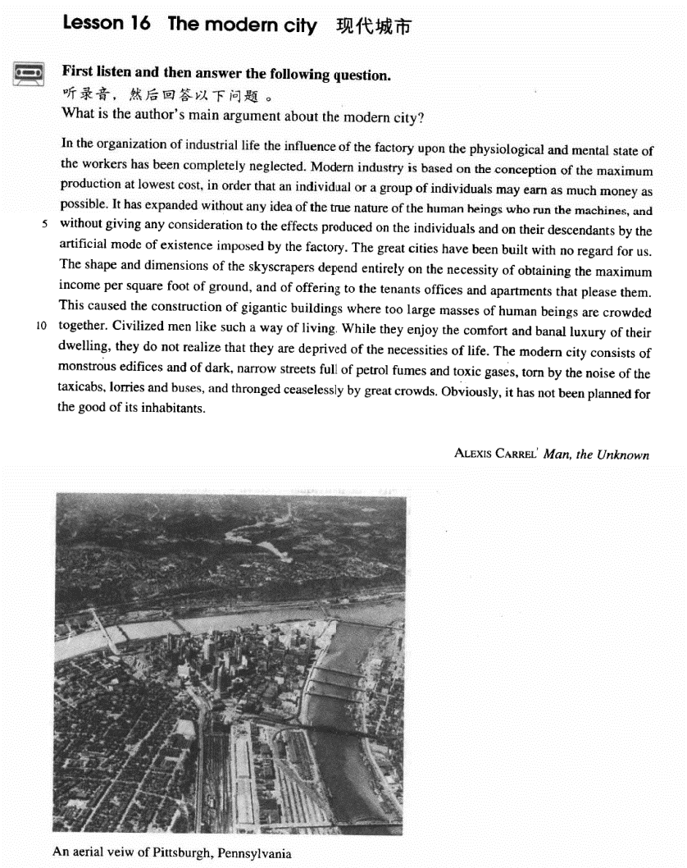

课文

In the organization of industrial life the influence of the factory upon the physiological and mental state of the workers has been completely neglected.

在工业生活的组织中，工厂对工人的生理和精神状态的影响完全被忽视了。

Modern industry is based on the conception of the maximum production at lowest cost, in order that an individual or a group of individuals may earn as much money as possible.

现代工业的基本概念是：以最低成本获取最多产品，为的是让某个个人或某一部分人尽可能多地赚钱。

It has expanded without any idea of the true nature of the human beings who run the machines, and without giving any consideration to the effects produced on the individuals and on their descendants by the artificial mode of existence imposed by the factory.

现代工业发展起来了，却根本没想到操作机器的人的本质。工厂把一种人为的生存方式强加给工人，却不顾及这种生存方式给工人及其后代带来的影响。

The great cities have been built with no regard for us.

大城市的建设毫不关心我们。

The shape and dimensions of the skyscrapers depend entirely on the necessity of obtaining the maximum income per square foot of ground, and of offering to the tenants offices and apartments that please them.

摩天大楼完全是按这样的需要修建的：每平方英尺地皮取得最大收入和向租房人提供使他满意的办公室和住房。

This caused the construction of gigantic buildings where too large masses of human beings are crowded together.

这样就导致了许多摩天大厦拔地而起，大厦内众多的人挤地一起。

Civilized men like such a way of living.

文明人喜欢这样一种生活方式。

While they enjoy the comfort and banal luxury of their dwelling, they do not realize that they are deprived of the necessities of life.

在享受自己住宅的舒适和庸俗的豪华时，却没有意识到被剥夺了生活所必需的东西。

The modern city consists of monstrous edifices and of dark, narrow streets full of petrol fumes and toxic gases, torn by the noise of the taxicabs, lorries and buses, and thronged ceaselessly by great crowds.

大得吓人的高楼和阴暗狭窄的街道组成了今日现代化的城市。街道上充斥着汽油味和有毒气体，出租汽车、卡车、公共汽车的噪音刺耳难忍，络绎不绝的人群挤来挤去。

Obviously, it has not been planned for the good of its inhabitants.

显然，现代化的城市不是这居民的利益而规划的。

词汇讲解

### consideration

* **consideration** [kən7sɪdə'reɪʃn] n.考虑

**give consideration to sth.** 考虑某事

* Please **give** careful **consideration to** the question.

**merit / deserve consideration** 值得考虑

* The plans **merit** / **deserve** serious **consideration**.

**under consideration** 考虑之中

* There are several amendments **under consideration**.

**beneath consideration** 不值得考虑

* It is a matter **beneath consideration**.

**take … into consideration / account** 把…考虑进去

### descendant

* **descendant** [dɪ'sendənt] n. 后裔，子孙
* He is a direct **descendant** of Confucius.

**【近义词】**表达“**后代**”：

**offspring** n. 后代，子孙；产物

* conflicts between parents and their **offspring**

**posterity** n. 子孙，后裔；后代

* These works of art are preserved for **posterity**.

**【扩展】**

**ancestor** n. 始祖，祖先；被继承人

**forefather** n. 祖先；前辈

**forebear** n. 祖先；祖宗

**predecessor** n. 前任，前辈

**successor** n. 继承者；后续的事物

* Bill Clinton is George W. Bush’s **predecessor**.
* George W. Bush is Bill Clinton's **successor**.

**【同根词】**

**descend** v. 下降

**ascend** v. 上升

* **in descending order**  降序
* **in ascending order** 升序

**【词组搭配】**

**be descended from …** 是…的后代

* We are all **descended from** Yandi and Huangdi.
* We are all **descendants of** Yandi and Huangdi.

**【扩展】**

**condescend** vi. 屈尊；俯就；（对某人）表现出优越感

* The general **condescended** to dine with the soldiers.

**transcend** vt. 胜过，超越

* The best movies are those which **transcend** national and cultural barriers.

### artificial

* **artificial** [7ɑ:tɪ'fɪʃl] adj. 人工的，人造的，假的
* **artificial** flowers / limbs / intelligence (AI) / respiration 人工…

**【扩展】【辨析】**

**synthetic** （强调化学合成）n. 合成物 adj. 综合的；合成的，人造的

* **synthetic** fibers / rubber

**simulated** （暗示廉价）adj. 模拟的；模仿的；仿造的

* **simulated** fur / jewels

**false** adj. 非天生的；人造的；假的

* **false** hair / teeth

**fake** / **counterfeit**adj. 假冒的，伪造的；虚伪的

* **fake** / **counterfeit** money

**forged** adj. 伪造的

* a **forged** signature

**pirated** adj. 盗版的

* **pirated** CDs / books / software

### impose

* **impose** [ɪm'pəʊz] n. 强加

**impose / force sth. on / upon sb.** 把…强加给某人

* Some parents **impose / force** their own moral values **on** their children.
* It **was** not **forced** **upon** them by the survival competition; they could have caught and lived on prey without using poison, just as the thousands of non-poisonous snakes still do.

**exert sth. on / upon sb.** 对某人施加…

* Advertising **exerts** a subtle influence **on** us.
* My wife **exerts** a lot of pressure **on** me to make more money.

**inflict sth. on / upon sb.** 把…（痛苦的事）强加给某人

* He always **inflicts** his company **on** me.
* Please don’t **inflict** your love **on** me.

**【词根】**

**“-pos”**= 放置

**impose**  vt. 强加；征税；以…欺骗；vi. 利用；欺骗；施加影响

**expose** vt. 揭露，揭发；使曝光；显示

**propose** v. 建议；打算，计划；求婚

**oppose**  v. 反对；对抗，抗争

**dispose**  v. 处理；安排

**interpose**      vt. 提出（异议等）；使插入；使干涉；vi. 干预；插入；调停

**depose**  v. 免职；作证；废黜

**compose**       v. 组成；作曲；排字

**decompose**  v. 分解；腐烂

**transpose**     v. 调换；移项；颠倒顺序

**juxtapose** v. 将……并列

### dimension

* **dimension** [daɪ'menʃn] [dɪ'mɛnʃən] n. 空间的量度

**dimensions** (the length, the width and the height of your room)

* Please specify the **dimensions** of your room.
* three-**dimensional** 三维
* the fourth **dimension** 思维

### skyscraper

* **skyscraper** ['skaɪskreɪpə(r)]n. 摩天大楼

**【近义词】**

**skyscraper** n. 摩天楼，超高层大楼；特别高的东西

**high-rise** n. 高楼；大厦；adj. 高楼的；超高层的

**edifice** n. 大厦；大建筑物

**edify** vt. 熏陶；启发；教诲

**【扩展】**表达“**建筑、住宅**”：

**mansion** 公馆；宅第

* A Dream of Red **Mansions** 红楼梦

**detached house** 独立屋；独立式房子；独立别墅

**Villa** 度假别墅

**semi-detached house** 半独立屋；半独立式住宅

**row house** / **town house** （主要居住在乡间者的）市内住宅，城内住宅

**bungalow** 平房；小屋

**cottage** 小屋；村舍；（农舍式的）小别墅

**hut** 小屋

**Igloo** （北美北部因纽特人的拱形圆顶）冰屋

### luxury

* **luxury** ['lʌkʃəri] n. 奢侈，豪华；奢侈品
* live in luxury / poverty 过着奢侈/贫困的生活

**【反义词】**

**necessity** n. 需要；必然性；**必需品**

* Limousines and perfume are **luxuries** whereas clothing, food, shelter and transportation are basic **necessities** of daily life.

**【同根词】**

**luxurious** adj. 奢侈的；丰富的；放纵的；特级的

= **fancy** adj. 想象的；奇特的；**昂贵的**；精选的

= **luxuriant** adj. 繁茂的；丰富的；**奢华的**；肥沃的

* **luxuriant** plants of the tropics

### deprive

* **deprive** [dɪ'praɪv] v. 剥夺

**deprive sb. of sth.** 剥夺某人某事（一般指权利）

* Some criminals are **deprived of** political rights.
* A man without an education, many of us believe, is an unfortunate victim of adverse circumstances, **deprived of** one of the greatest twentieth-century opportunities.

**【近义词组】**表达“剥夺某人某事”：

**strip / divest sb. of sth.**

**dispossess sb. of sth.** （只能指财产）

* The nobles were **dispossessed of** their estates.

**disinherit sb.** 剥夺继承权

* He has **disinherited** his eldest son.
* Hart’s good-bad man was always an outsider, always one of **the disinherited**, …

**【派生含义】**表达“**贫穷的**”：

**deprived** adj. 贫穷的；贫困的；穷苦的

**disadvantaged** adj. 弱势的；社会地位低下的

**underprivileged** adj. 贫困的；被剥夺基本权力的；社会地位低下的

**impoverished** adj. 贫乏的；贫瘠的；枯竭的

**destitute** adj. 贫困的；贫穷的；赤贫的

### toxic

* **toxic** ['tɒksɪk] adj. （书面语）有毒的
* **toxic** chemicals / substances / exhaust fumes

**【近义词】**表达“**有毒的**”：

**noxious** 有毒的；有害的

* Carbon monoxide is a colorless, odorless and **noxious** gas.

**venomous** 分泌毒液的；有毒的

* **venomous** snakes / insects
* She has beautiful eyes but a **venomous** tongue.

**intoxicate** vt. 使陶醉；使喝醉；使中毒

* He was thoroughly **intoxicated**.
* He was **intoxicated by / with** success.
* **Intoxicated by** his success, Harry then asked for perfumed mud.

### throng

* **throng** [θrɒŋ] v. 挤满人
* Tourists **thronged** the Imperial Palace.

**be thronged / crowded / packed with …**被挤满了…

* The streets **were thronged / crowded / packed with** Christmas shoppers.

**be swarming / teeming with …** 挤满了…

* The campus **was swarming / teeming with** students.

课文讲解

# （标题）

# The modern city

知识点（1）课文作者介绍

**Alexis Carrel** **French surgeon and Nobel laureate**

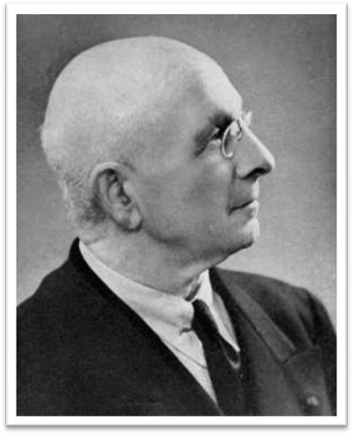

知识点（2）课文背景介绍

**The text is an excerpt from ‘Man the Unknown’. Alexis wrote ‘Man the Unknown’ in 1935,expounding his elitist philosophy.**

# （第一段）

# In the organization of industrial life the influence of the factory upon the physiological and mental state of the workers has been completely neglected.

**语法分析：**

In the organization of industrial life（时间状语） the influence *of the factory upon the physiological and mental state of the workers**（后置定语）* has been completely neglected.

知识点（1）Lesson03-27

**in sth. / doing sth.** 在…的过程中

**in doing = in the process of doing** 在…的过程中

* In trying to solve one problem, I created another.
* **In seeking independence**, they do not sacrifice their human dignity.

**【复习】**Lesson03-14 **介词in表示目的**

**in return/reward for …** 作为报答，以换取、以报答

* America helped the rebels**in return for** their promise to support democracy.
* He is always willing to help people out, without expecting anything **in return**（作为报答）.

**in exchange for …** 以换取

* They were given food and shelter**in exchange for** work.

**in compensation for …** 以补偿

* She received $10,000**in compensation for** her injuries at work.

**in memory of （死者）…** 以追忆死者

* He wrote a long poem **in memory of** his late wife.

**in honor of …** 以尊敬

* The college was named **in honor of**George Washington.
* a banquet **in honor of**the president.

**in appreciation of …**  以感激

* I sent him a gift **in appreciation of** his help.

**in recognition of …** 以表彰

* He was awarded one of the ‘Ten Outstanding Young Persons’ **in recognition of** his significant achievements.

知识点（2）

**industrial** adj. 工业的，产业的

**industrious** adj. **diligent** 勤勉的

知识点（3）

… the **influence** *of the factory* **upon** *the physiological and mental state of the workers（后置定语）*has been neglected …

**the influence of …A… on / upon …B…** A对B的影响

* the **influence** of parents **on** / **upon** their children

**【****近似词组】**

**the effect of …A…on / upon …B…** A对B的影响

* the **effect** of fertilizers **on** / **upon** the crops

**the impact of …A…on / upon …B…** A对B的影响（重大的影响）

* the **impact** of the oil spill **on** / **upon** marine life

**【扩展】**介词

**“对于…”** 用介词**to**

**devotion / dedication to …** 对于…的贡献

* a teacher’s **devotion / dedication to** his work

**loyalty / allegiance to…** 对于…的忠诚

* swear an oath of **loyalty / allegiance to** the queen

“**感情**”相关的词汇后面的介词通常用**for**

**love / affection for …**  对…的爱

**zest / passion / enthusiasm for …** 对…的热情

**pity / compassion / sympathy for …**  对…同情

知识点（4）

**写作**：整个这句作为“主题句（topic sentence）”；后面用“示例（supporting sentences）”做支撑

# Modern industry is based on the conception of the maximum production at lowest cost, in order that an individual or a group of individuals may earn as much money as possible.

**语法分析：**

Modern industry is based on the conception of the maximum production at lowest cost（介词of引出同位语）, **in order that（以便于）** an individual or a group of individuals may earn as much money as possible. （目的状语从句）

知识点（1）

**conception** n. 怀孕；概念；设想；开始

**conceive** t. 怀孕；构思；以为；持有

**concept** n. 观念，概念

知识点（2）

production 产量

* increase **production** 提升产量
* increase the amount of（缀词，production本身就有产量的含义） production

**【扩展】**Lesson04-07（赘词）

**写作：**避免出现赘词

**with experience** （固定搭配）随着经验的积累

~~with accumulating experience~~ X 错误搭配（赘词）

* **With experience**, and with improved apparatus, it is now possible not only to locate a shoal but to tell if it is herring, cod, or other well-known fish, by the pattern of its echo.

**with time** 随着时间的流逝、逐渐地、慢慢地

* ~~with passing time~~ X 错误搭配（赘词）

**with seasons** 随着季节地更替

* ~~with changing seasons~~ X 错误搭配（赘词）
* the cause of justice（抽象词） 正义事业
* ~~the cause of~~（多余） national reunification（实意词） X 错误搭配（赘词）
* accelerate ~~the speed of~~ economic reform X 错误搭配（赘词）
* The captain knew that his attempt would not be the only attempt. （重复）
* The captain knew that his attempt would not be the only one. （没有简洁多少）
* The captain knew that **his** would not **be the only attempt**. （简洁）
* Our age is a tragic age. （重复）
* Our age is a tragic one. （没有简洁多少）
* **Ours** is **a tragic age**. （简洁）—— Shakespeare

知识点（3）

an individual or a group of individuals

**the boss** 老板

**board of directors**  董事局

知识点（4）Lesson03-55

**语法：for…to do 介词for**引出动词不定式的逻辑主语

* He opened a door and stood aside for *her* to pass.
* Her circumstances had never been good enough for ***her hopes*** to be realized.
* **课文写法替换：**
* …, **for** an individual or a group of individuals **to** earn as much money as possible.

# It has expanded without any idea of the true nature of the human beings who run the machines, and without giving any consideration to the effects produced on the individuals and on their descendants by the artificial mode of existence imposed by the factory.

**语法分析：**

It has expanded without any idea of the true nature of the human beings who run the machines（who...定语从句）, **and（并列状语）** without giving any consideration to the **effects** **produced**（过去分词短语做后置定语） on the individuals and on their descendants ***by***（介词短语当后置定语，修饰effects及produced…后面的） *the artificial mode of existence imposed by the factory（过去分词短语做后置定语）*.

知识点（1）

**expand** v. **英文解释：**to become larger in size, number or amount 扩展

**contract【反义词】** 收缩

* **expand** business / one’s chest
* The eagle **expanded** its wings.

**【近义词】**

**stretch** vt. 伸展,张开

* The forest **stretched** all the way to the horizon.
* He yawned and **stretched**.

**stretch one’s legs** 舒展腿

* You can **stretch your legs** on the spacious decks, …

**dilate** 扩大；（使）膨胀，扩张

* **dilated** pupils
* The medicine will **dilate** blood vessels.

**inflate** 使充气；膨胀

* He used a bicycle pump to **inflate** the ball.

**inflation** n.货膨胀；通胀率；充气

**magnify** v. 放大

* This microscope will **magnify** objects up to 100 times.
* **magnifying** glass

**amplify** 放大，增强（声音等）

* The sound is **amplified**.
* The signals are **amplified**.

**amplifier** 放大器；扩音器；扬声器

知识点（2）

* **课文写法替换：**
* … **without any idea of the true nature of** the human beings …
* … **without giving any consideration to**（考虑） the true nature of human beings …
* … **totally neglecting** （完全忽略）the true nature of human beings …
* **课文写法替换：**
* physiological and mental state
* physical and spiritual well-being

知识点（3） **give + 名词 + to**

**give consideration to …** 考虑…

= **give thought to …**

**【扩展】【复习】**

**give rise to …** 导致

* This can **give rise to** curious situations, as it did in the case of Alfred Bloggs who worked as a dustman for the Ellesmere Corporation.

**give birth to …** 生孩子

**give way to …** 取代…

* Steam trains **gave way to** electric trains.
* What a relief it was when the boulders suddenly disappeared, **giving way to** a stretch of plain where the only obstacles were clumps of bushes.

**give credit to …** 给某人赊账

* The shop **gives credit to** its customers.

知识点（4）

**mode** n. **particular way** or **manner** 模式

* **mode** of life / existence / thought
* Set the monitor to 256 color **mode**.

知识点（5）本句话的翻译：

它（现代工业）的扩张完全没有考虑到操作机器工人的本质，工厂把一种人为的生存方式强加给工人，却不顾及这种生存方式给工人及其后代带来的影响。

# The great cities have been built with no regard for us.

知识点（1）

**写作**：课文表达“**没有考略到**”的不同替换

neglect …

without any idea of …

without giving any consideration to …

with no regard for …

# The shape and dimensions of the skyscrapers depend entirely on the necessity of obtaining the maximum income per square foot of ground, and of offering to the tenants offices and apartments that please them.

**语法分析：**

The shape and dimensions of the skyscrapers depend entirely on the necessity of obtaining the maximum income per square foot of ground（of… 后置定语1）, and of offering to the tenants（状语前置） offices and apartments *that please them（that ...定语从句）*（of… 后置定语2）.

知识点（1）

**the necessity of doing sth.** 做某事的必要性

* The report stresses **the necessity of** eating plenty of fresh fruit and vegetables.
* **通俗表达：**
* The report stresses **that it is necessary to** eat plenty of fresh fruit and vegetables.

**out of necessity** 出于必要

* Women increasingly went out to work, usually **out of** economic **necessity**.

**be a necessity** 必须要…

= **be necessary**

* For most people, a good guide book **is a necessity** when traveling.

= **be a must**

* **听力真题：**

A. Move to a cheaper apartment.

B. Find a person to share their apartment.

C. Hire a new worker.

D. Write an accurate description of a friend.

* W1: What we need is a roommate who is neat and considerate.
* W2: Let’s write that in the ad: neat-ness and consideration **a must**.
* Q: What do the speakers hope to do?
* Answer: (B) Find a person to share their apartment.

**【扩展】**

**compulsory** （因法律或规则而）必须做的，强制的，强迫的

* a **compulsory** course 必修课
* an optional / elective course 选修课
* There are no 'illiterates' —if the term can be applied to peoples without a script—while our own **compulsory school attendance**（义务教育） became law in Germany in 1642, in France in 1806, and in England in 1876, and is still non-existent in a number of 'civilized' nations.

知识点（2）

**offer sth. to sb.** 给某人提供某事

**课文改变正常语序**

# This caused the construction of gigantic buildings where too large masses of human beings are crowded together.

知识点（1）

**mass** n. throng; a large crowd 一大群人

* a **mass** / **throng** of people
* **mass** education 群众教育
* **mass** media 大众传媒
* weapons of **mass** destruction 大规模杀伤性武器
* problems of **mass** unemployment 大规模失业问题

# Civilized men like such a way of living.

# While they enjoy the comfort and banal luxury of their dwelling, they do not realize that they are deprived of the necessities of life.

**语法分析：**

**While（尽管）** they enjoy the comfort and banal luxury of their dwelling（让步状语从句）, they do not realize *that they are deprived of the necessities of life**（that… 宾语从句）*.

知识点（1）Lesson03-06 **让步状语从句**

**while 在书面语中做连词，特别是放在句首，后面又出现了现在时；一般表“尽管，即使”，引导让步状语从句**

**= Although** / **Though**

* **While** they enjoy the comfort and banal luxury of their dwelling, they do not realize that they are deprived of the necessities of life
* **While**she is a likable girl**,** she can be extremely difficult to work with.
* **While** they enjoy the comfort and banal luxury of their dwelling, they do not realize that they are deprived of the necessities of life.
* **While** the quality of legal journalism varies greatly, there is an undue reliance amongst many journalists on interpretations supplied to them by lawyers.
* **While** comment and reaction from lawyers may enhance stories, it is preferable for journalists to rely on their own notions of significance and make their own judgments.
* **While** Washington and Jefferson privately expressed distaste for slavery, they also understood that it was part of the political and economic bedrock of the country they helped to create.

**while / whereas** conj. 而 （做连词，轻微转折）

* He must be over 60, while / whereas his wife looks about 30.
* One man stayed at the wheel **while** two others with black stockings over their faces jumped out and smashed the window of the shop with iron bars.
* **课文写法替换：**
* Although / Though they enjoy the …..
* **考研英语（英译汉）：**
* **While**（尽管） the quality of legal journalism varies greatly, there is an undue reliance amongst many journalists on interpretations supplied to them by lawyers. **While** （尽管）comment and reaction from lawyers may enhance stories, it is preferable for journalists to rely on their own notions of significance and make their own judgments.

知识点（2）

dwelling 住宅（优雅表达）

* my humble **dwelling**

**residence** / **domicile**n. 住宅，住处；居住（优雅表达）

**dwell**（居住） / **dweller**（均没能）

* city **dwellers**

知识点（3）

**the necessities of life** 指的是：

the clean atmosphere, the closeness to nature, the intimacy of people, etc.

But city dwellers are deprived of all these valuable things in the concrete jungle.

# The modern city consists of monstrous edifices and of dark, narrow streets full of petrol fumes and toxic gases, torn by the noise of the taxicabs, lorries and buses, and thronged ceaselessly by great crowds.

**语法分析：**

The modern city consists of（并列consists of） monstrous edifices and of（并列consists of） dark, narrow streets full of petrol fumes and toxic gases（后置定语；streets修饰语1）, torn by the noise of the taxicabs, lorries and buses（后置定语；streets修饰语2）, and thronged ceaselessly by great crowds（后置定语；streets修饰语3）.

知识点（1）

表达“由…组成”：

**consist of …**

**be made up of …**

**be composed of …**

**comprise …**

**comprise …**

**make up …**

**compose …**

**constitute …**

知识点（2）

petrol fumes 和 toxic gases

表达：air pollution

torn by the noise of the taxicabs

表达：noise pollution

thronged ceaselessly by great crowds

表达：the problem of overpopulation

知识点（3）

**tear** 打破

* a country **torn** by war

# Obviously, it has not been planned for the good of its inhabitants.

知识点（1）

**写作：**总结句（concluding sentence）

对应第四句（主题句）：The great cities have been built with no regard for us.

知识点（2）

表达“**为了…的利益**”：

**for the good of …**

**for the sake of …**

**for the benefit of …**

**in the interest of …**

**on behalf of …**

知识点（3）课文写作总结

主题句topic sentence

扩展句supporting sentences

总结句concluding sentences